GPC Perpetual Cycle Count
Functional Specification

Prepared by :

Ricardo Abainza

Version 1.1

Table of Contents
1. Introduction 3
2. Document Management 3
3. Approval 3
4. Project Objective 4
5. Process Flow Diagram 5
6. System Overview 5
7. Reports (OPS to Confirm the Reports requirements and layout) 7
8. Over all System Charateristics 7
9. Appendix 7

Introduction

This Document defines the functional specification of the GPC Perpetual Cycle Count Application.

Document Management

History

Date | Version | Comments | Signature
12 Nov 2003 | 1.0 | Initial Version
24 Nov 2003 | 1.1 | Revised Version

Approval
Name | Title | Signature Date
Wu Wei Yan | Devt Manager
Balakrishnan Govindasamy | GPC Operation Manager

Project Objective

- To develop a system that will facilitate the perpetual cycle count for Epson GPC Operation. Currently, the operation is doing a random cycle count for the warehouse.

- Following issues are encountered during the random cycle count process.
- Operation cannot freeze the movement of inventory, which will sometimes lead to confusion especially to the counter.
- The inventory cannot be differentiated among existing inventory, the new incoming lots and picked inventory after the counting.
- Tracing of movement transactions of the specific location through the Exceed system requires much effort and time.

- With the GPC Perpetual Cycle Count project, we target to resolve the above issues by providing the new system and process:
- A controlled cycle count for every aisle in the warehouse is only allowed at any one time.
- A report that will monitor all the movement transactions of inventory for each affected location during a cycle count is designed.
- Incoming inventory will not be put away in the location when the location is under the cycle count mode.
- Outgoing inventories will still be reflected in the cycle count report so that the counting personnel will know how much inventory has been picked before and after the counting.

- Schedule and Milestones

SNo | Item | Man day
 | Functional Spec | 2
 | Database Design | 1
 | Development
 | Screen Design/layout | 1
 | Cycle Count Main functionalities | 5
 | Reports (Ops to specify) | 5
 | Full Testing | 2
 | Demo | 1
 | Test Document | 3
 | UAT Setup | 1
 | UAT | -
 | User Guide | 2
 | Production Setup | 1
 | TOTAL | 29

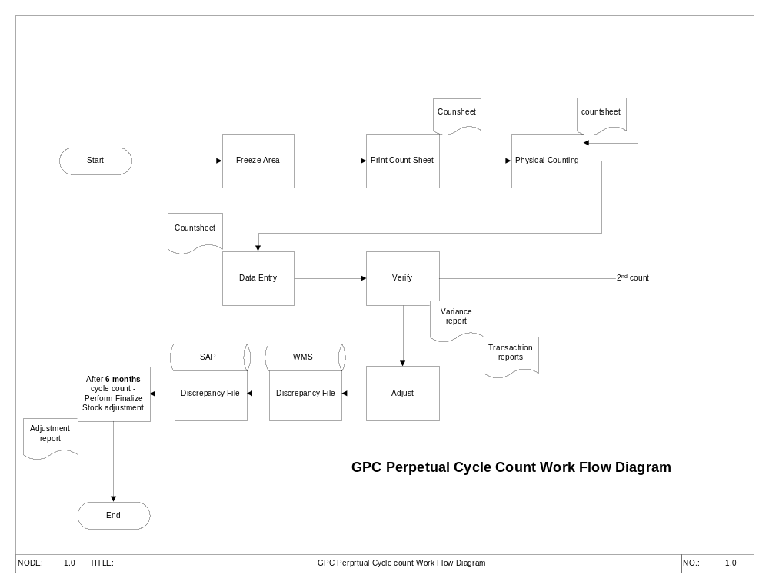Process Flow Diagram

System Overview
  - System Security
    - Login will be based on the existing Exceed Login. Users who have existing GPC access will be able to use this system.

  - Search
    - Users can do system search on those cycle count that has been completed.
    - For each search result, user can see the information and criteria of each cycle count.

  - Initiate Cycle Count
    - Cycle Count can be initiated (open) upon clicking a button. This procedure will trigger a check on whether there is an existing or open cycle count in the system. If there is an opened or pending cycle count, the system will reject the initiation of the cycle count. Otherwise, the initiation will go through.
    - Once the initiation has been done. Users can now select the criteria of the initiated cycle count. At this point, the user has to choose which aisle (row) or set of aisle he wants to freeze. If the user wants to freeze more than one aisle, the aisle should be in consecutive order i.e. (10,11,12…). The system will not allow freezing of non-consecutive aisle.
  - Freezing
    - The user has to click the freeze button to start freezing the specific area. Upon freezing, no put away will be allowed to those affected locations unless the cycle count is completed (closed) or cancelled. Picking will not be affected by the freezing. Once frozen, a running number will be generated (Cycle Count Key). This number will be used in accessing the specific cycle count for all transactions and reports.

  - Printing of Cycle Count
    - After freezing, user can print the cycle count using the generated cycle count key. Printing a cycle count sheet can be invoked at any point in the process as long as the freezing has been done.
    - Cycle count printouts will be sorted by Aisle (rack) Tier (odd or even) and Level (A, B, C…) respectively.
    - Printouts will be blind cycle count sheets, which means the system quantity will not be shown on the cycle count sheets.

  - Physical Counting
    - This procedure do not requires system.

  - Data Entry
    - For the data entry, user has to retrieve the specific cycle count and select the respective tier and level. For every specific criteria, all the locations meeting the criteria will be shown on the screen for the data entry personnel to populate the counted qty data. This screen will have the capability of sorting findings and filtering to the users’ convenience. The screen will use color coding for the users to see which are the fields that has not been populated and records with variances. This is to ensure that the user will input the correct data in the system. If a counted physical inventory is not reflected in the system, the user can add a new record and put the necessary information on that new record.

  - Verification
    - User has to print the variance report. Variance report will only show records that has variance. Operation can do a secondary verification if the variance is correct. Upon verification, user can still modify the counted qty in the data entry screen.

  - Finalize
    - Once the data entry and verification is completed, user can finalize or close the cycle count. Closing a cycle count will lock the cycle count and no more modifications will be allowed.
    - Upon finalizing, variance qty will be moved to a special location(to be discussed) in WMS. These variances will then be staying in the location until Epson gives the green light to reflect these variances to master inventory.
    - For negative discrepancy (Physical inventory is missing but reflects in the system), the qty will be moved in the special location and put it onhold.
    - For Positive discrepancy (excess inventory) – Ops to decide on what to do.

Reports (OPS to Confirm the Reports requirements and layout)
- Users can invoke a list of reports on the system
  - Count Sheet - The cycle count book
  - Variance report - Variance Report for each count book
  - Master Variance - Master Variance report
  - Final discrepancy - Final discrepancy Report
  - Summary Report - Summary Report
  - Others - Ops to Confirm

Over all System Characteristics
- Security Levels
  - Only Users that has access to GPC Smart will be able to use the system
- Hours of system availability
  - The system will be available 24x7. However, there would be a maintenance period where system will not be available.
- Locations
  - The system can be accessed at any premises as long as connected to BAX Network via the BEEF Applications and I.E. (to be added)

Appendix
- List of Status
- Open - The cycle count is New
- Initiated - The cycle count is already initiated(Frozen)
- Closed - Cycle Count is Finished/Finalized
- Cancelled - Cancelled Cycle Count

